|  |  |
| --- | --- |
| ccc-logo | **Year 12 *ATAR* Physics 4** **2018**  ***Evaluation and Analysis***  ***5.0%***  **NAME: ………………………………………………….**  Data: See Data Sheet  Approx. marks shown.  ***(50 marks)*** |

**Part B** **Quiz**

|  |  |
| --- | --- |
| 1. (a) A black body in the laboratory may consist of a hollow porcelain sphere with a small hole in it.   The inside is blackened with soot. A beam of light is directed at the sphere so that it strikes the hole at an angle. The beam of a variety of wavelengths bounces around the inner walls and is entirely absorbed by the sphere.  Explain why the hole is considered to be a black body. [1] | _Pic1 |

..........................................................................................................................................

..........................................................................................................................................

(b) In 1896, Wien found that the product of the temperature of a black body and the wavelength of the emitted radiation produced a constant: 2.90 x 10–3. This relationship is known as Wien's displacement law.

(i) Write this formula as a mathematical relationship. [1]

….......................................................................................................................................

….......................................................................................................................................

(ii) Calculate the peak wavelength which corresponds to 1400 K using Wien's displacement law. [2]

….......................................................................................................................................

….......................................................................................................................................

….......................................................................................................................................

(c) In 1900, another scientist described the process more accurately by including the constant ***h*** with a mean value of 6.626 x 10–34 Js. It was from this radiation equation that this scientist developed the basis for what we know as quantum theory.

Suggest the name of this scientist. [1]

….......................................................................................................................................

1. As a blackbody heats up, it emits all of the energy it has received back into space. Although all wavelengths are emitted, the dominant wavelength directly corresponds to the effective surface temperature of the black body according to Wien's displacement law.

The table below was the result of an experiment in black body radiation. The coordinate pairs give a curve corresponding to an effective surface temperature (***Teff***) of 1400 K.

|  |  |  |  |  |  |  |
| --- | --- | --- | --- | --- | --- | --- |
| ***E*** | 1.5 | 4.5 | 8.0 | 5.5 | 3.0 | 1.0 |
| **λ** | 1000 | 1500 | 2000 | 3000 | 4000 | 5000 |

where ***E*** = the emissive power in Wm–2 nm–1 x 10–9, and

**λ** = wavelength in nanometres.

On the grid on pg 3 draw a graph of the black body radiation curve for 1400 K, plotting emissive power on the y axis and wavelength on the x-axis.

Use the answer to question 1 (b) (ii) to estimate the turning point of the curve. [4]

1. (a) Use Wien's displacement law to establish the peak wavelengths when:

|  |  |  |  |
| --- | --- | --- | --- |
|  | ***E*** | ***Teff*** | **λ** |
| (i) | 18 | 1600 |  |
| (ii) | 4 | 1200 |  |
| (iii) | 2 | 100 |  |

where ***E*** = the emissive power in Wm–2 nm–1 x 10–9, and

***Teff*** = is in Kelvin. [3]

1. Plot these points on the graph in question 2 and join them up with a curved line. This represents the peak radiation for a given temperature.
2. Earth, however, is not a perfect black body but a grey body which absorbs and emits about 90% of the radiation it receives from the sun. Earth is therefore regarded as having an emissivity (***ε***) of 0.9.

The surface temperature (***Teff***) of Earth is 310 K and the radius is 6000 km calculate the total outgoing radiation using ***P = A ε E*** where A is the area of the surface, 4 π r2 and ***E*** is the energy derived from Stefan's Law, ***E*** = **σ *T*4**. Stefan's constant (**σ**) has the value

5.75 x 10–8 W m–2 K–4. [3]

..........................................................................................................................................

..........................................................................................................................................

..........................................................................................................................................

..........................................................................................................................................

..........................................................................................................................................

..........................................................................................................................................

18

16

14

12

10

8

6

4

2

0



1. Use the Data Sheet to complete the table below relating the wavelength ranges, in m, associated with ultraviolet (uv), visible, infrared, and microwave spectra. [4]

|  |  |  |
| --- | --- | --- |
| **EM radiation spectrum** | **Min wavelength**  **(m)** | **Max wavelength**  **(m)** |
| Ultraviolet |  |  |
| Visible |  |  |
| Infrared |  |  |
| Microwave |  |  |

1. What wavelength spectrum is associated with heat radiation? Give an example of a device that relies upon detecting these wavelengths. [2]

..........................................................................................................................................

..........................................................................................................................................

1. Convert a normal human body temperature of 37°C to Kelvin. Only whole numbers are required. [2]

..........................................................................................................................................

* + - 1. Use the blackbody spectrums on the following pages to complete the table below. ***Remember to include units***.

Note that the *peak wavelength* is the x-axis value corresponding to the maximum of the blackbody intensity curve. [8]

|  |  |  |  |
| --- | --- | --- | --- |
| **Object** | **Temperature** | **Peak wavelength** | **The primary peak spectrum region** |
| Sun |  |  |  |
| Light bulb |  |  |  |
| Oven |  |  |  |
| Yourself |  |  |  |
| Earth |  |  |  |

**Black body Spectra**

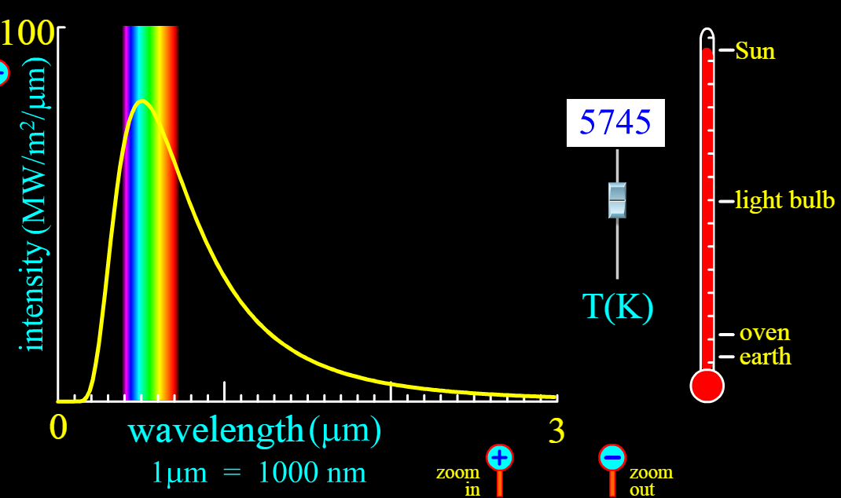

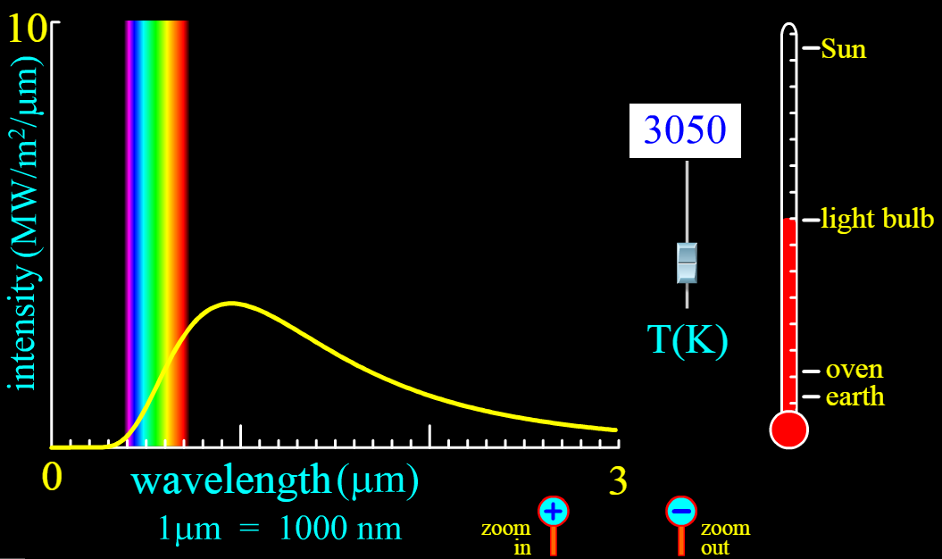

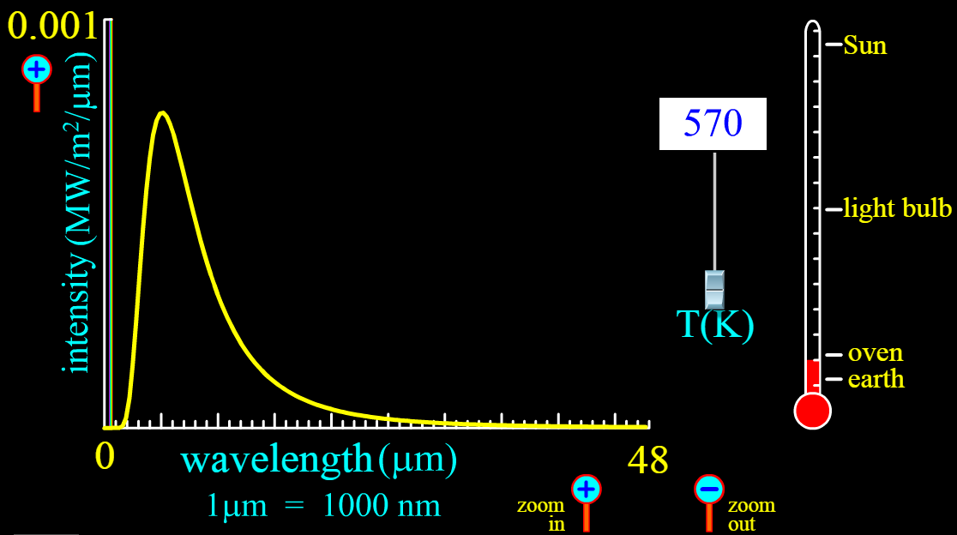

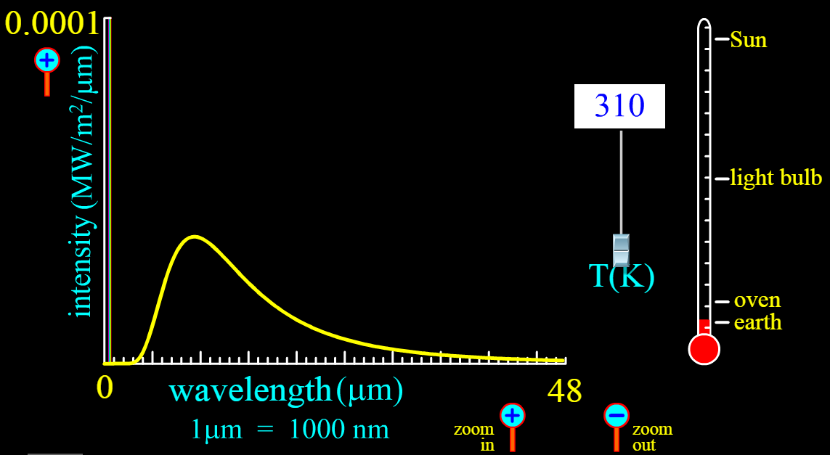

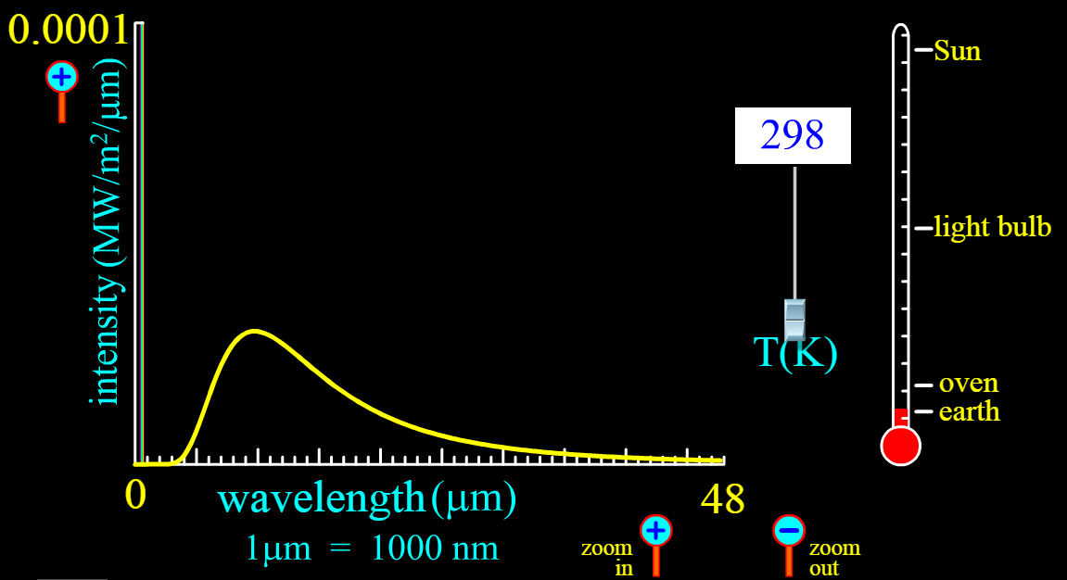

1. Which of the above bodies mostly radiate visible light and which bodies will mostly radiate heat? [2]

..........................................................................................................................................

..........................................................................................................................................

1. Do incandescent light bulbs radiate more light or more heat? [2]

..........................................................................................................................................

..........................................................................................................................................

..........................................................................................................................................

# In summer people are advised to stay out of the sun with SunSmart Campaigns such as

# Slip! Slop! Slap! Throw on a hat!

By referring to the spectrum of the Sun above, explain the need for this campaign. [2]

..........................................................................................................................................

..........................................................................................................................................

..........................................................................................................................................

..........................................................................................................................................

1. The area under the curve (i.e. the size of the space under the yellow curve) represents the net energy radiated out of a blackbody at the selected temperature.

Consider the following black body spectrum, and assuming that the curve is a triangle, calculate net energy radiated out of a blackbody at the selected temperature.

***Remember to include units***. [4]

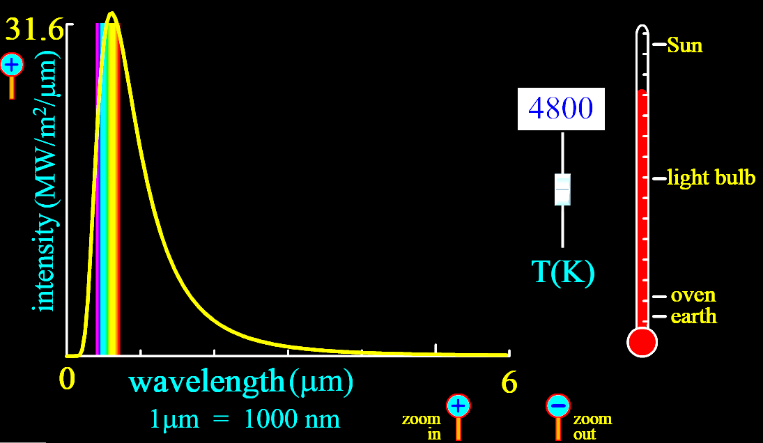

..........................................................................................................................................

..........................................................................................................................................

..........................................................................................................................................

..........................................................................................................................................

..........................................................................................................................................

1. Astronomers regard stars as near-perfect black bodies. A perfect black body will absorb all incoming radiation and emit all outgoing radiation.

(a) Use Wien's displacement law to find the effective surface temperature of the star Rigel if the peak wavelength is 263 nm. [2]

..........................................................................................................................................

..........................................................................................................................................

..........................................................................................................................................

(b) When observing Rigel what colour would one expect to see? [1]

A A red star

B A yellow star

C A blue star

1. Briefly explain the ultraviolet catastrophe originally associated with Blackbody radiation.

[4]

..........................................................................................................................................

..........................................................................................................................................

..........................................................................................................................................

..........................................................................................................................................

..........................................................................................................................................

..........................................................................................................................................

..........................................................................................................................................

..........................................................................................................................................

..........................................................................................................................................

..........................................................................................................................................

..........................................................................................................................................

..........................................................................................................................................

End of Quiz